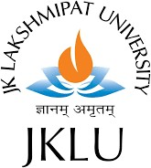JK LAKSHMIPAT UNIVERSITY, JAIPUR

**BTech Semester VI**

Software Engineering CS1113

**Assignment -2**

**TITLE –** SMART DOCUMENT CAPTURE PLATFORM

**Faculty Guide** – **Dr. Amit Sinhal**

# Prepared by:

Nikhil Gupta (2019BTechCSE033)

Sahil Namdeo (2019BTechCSE047)



